**Covid-19 Tracker Final Report**

1. **Introduction**

The objective of this project is tracking the deaths, infected people, recovered people due to the Covid-19 virus throughout India and displaying it through a simple website. This would enable anyone from India to see the state-wise data, patient details of those who are affected by the virus.

The following are the software requirements:

1. State-wise data: Indian map using will be displayed using a JavaScript library like Chart.js and when a user hovers on a state, the user will get the details of deaths, covered and infected people in that state.

2. Patient data: Details about infected patients, way of transmission, place will be displayed which helps users to check if there are any infected patients in their area.

1. **Design and Implementation**

Since this application required E-commerce based solution, PHP and MySQL was chosen as the backend technologies of the website. To implement quick front-end development, Bootstrap 4 was used as the CSS framework and lot of other CSS libraries were used which will be discussed below.

Libraries and tools used:

1. OwlCarousel: OwlCarousel is a jQuery plugin used to implement Carousel sliders in the web application.
2. Animate.css: Animate.css is a CSS library used to implement different animations which is very pleasing to the user and creates an amazing user experience.
3. Bootstrap: Bootstrap is a CSS framework that helps in quick development of front-end projects.
4. Font-Awesome: Font-Awesome is a icon library that provides with thousands of icons that creates an awe inspiring user experience.

Screenshots:

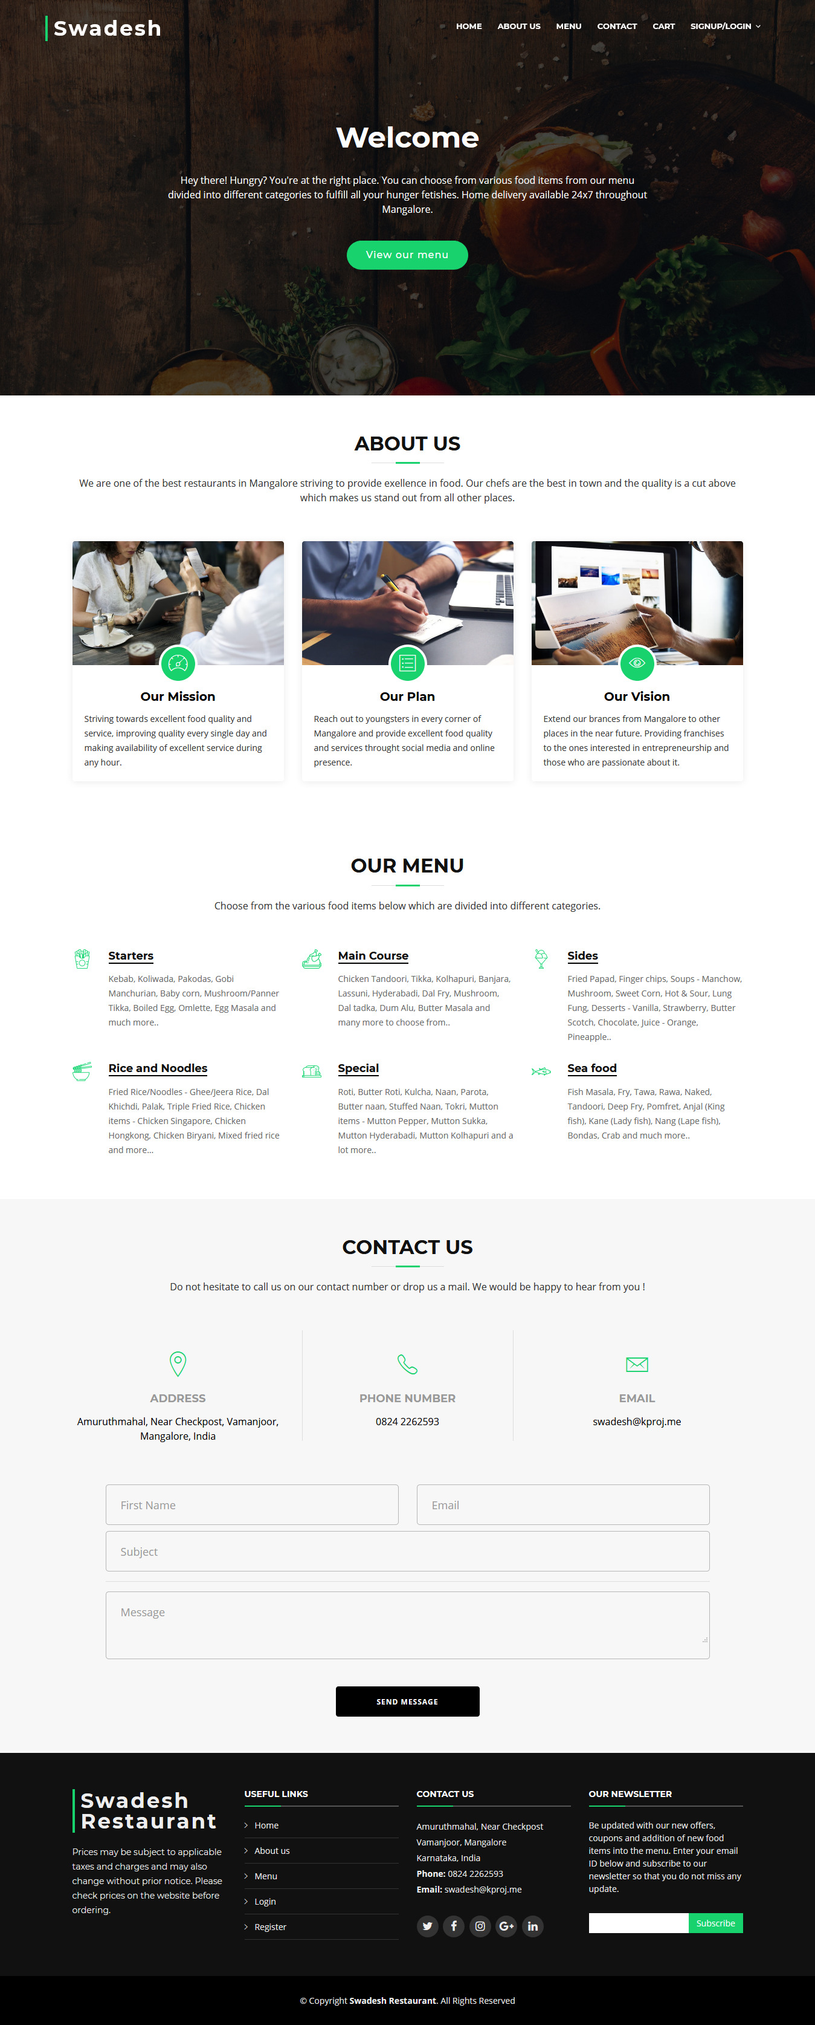

1. **Conclusion**

Project Outcome:

This project enabled the restaurant to deliver its food products to its customers seamlessly at any time of their choice. Online food ordering mediators like Swiggy, Zomato do not operate after 12 AM, but this project enabled the restaurant to deliver food even after midnight.

The restaurant achieved independence in choosing its own pricing and own way of operating. They weren’t forced to apply discounts like how it happens when operating with the mediators.

1. **References**

[www.ieee.org](http://www.ieee.org)

[www.stackoverflow.com](http://www.stackoverflow.com)

[www.wireframe.cc](http://www.wireframe.cc)

developer.paytm.com